Guy McClellan
HIST 500- Jeff Erbig
29 April 2016
“A Natural Culminating Point”: Tropics, Transportation, and the Panama Railroad, 1848-1877
Ironically, the United States’ first transcontinental railroad went through another country. The Panama Railroad, completed in the 1850s, joined with increasingly prominent steamship companies to connect America’s Atlantic and Pacific coasts. While it was no doubt a prescient idea, the Panama Railroad Company also had impeccable timing; it was incorporated the same year as gold was discovered at Sutter’s Mill, California, thereby spreading “gold fever” far and wide. The railroad connected America’s Atlantic and Pacific coasts during this period, only to be undermined by the first transcontinental telegraph (1861) and the joining of the Union Pacific and Central Pacific at Promontory Point, Utah (1869). Nevertheless, for some twenty-odd years, the United States relied on a private business venture in Central America to carry passengers, gold, and mail (amongst other things) from one coast to another—and thus fulfill the promise of a nation stretching “from sea to shining sea.”
Two documents from either end of the railroad’s heyday—an investment prospectus (1849) and Fessenden N. Otis’s official history (1861)—assist in contextualizing the transnational project. Both contain environmental determinism regarding tropical climates; heat and humidity supposedly fostered certain traits, and thus the environment was thought to determine the outlook and temperament of its residents. Equally important, I argue, is the underlying system of shared spatial logics espoused in each document. Essentialist American ideas about the tropics were inextricable from arguments regarding Panama’s geographic destiny as a connector of two oceans. If we read these promotional texts spatially, they reveal a tension between tropical exoticization and economic efficiency. I will demonstrate how both documents treat Panama (as a geographic location) separate from its jungle environs to serve their respective promotional purposes.
The History of the Railroad
The isthmus of Panama has been important for countless world systems. In the early colonial period, the Spanish imported slaves from Nicaragua to create roads across the isthmus; these routes proved essential for shipping Peruvian silver back to Europe. America was thus relatively late to the game. As early as 1835, Henry Clay requested that President Andrew Jackson open relations with Central America and, in particular, Nueva Granada—a republic containing present-day Colombia and Panama, as well as smaller parts of Venezuela and Ecuador. Nueva Granada granted exclusive rights to building a highway, railroad, or canal to a French company in 1838; however, political instability and insufficient capital impeded any real progress. The central government, located in Bogota, did little to assist in the matter.
It was not until 1848 that the United States cemented its claim to Panama’s transportation advantages. Under the Bidlack-Mallarino treaty,
The government of New Granada guarantees to the government of the United States that the right of way or transit across the Isthmus of Panama, upon any modes of communication that now exist, or that may be hereafter constructed, shall be open and free to the government and citizens of the United States.

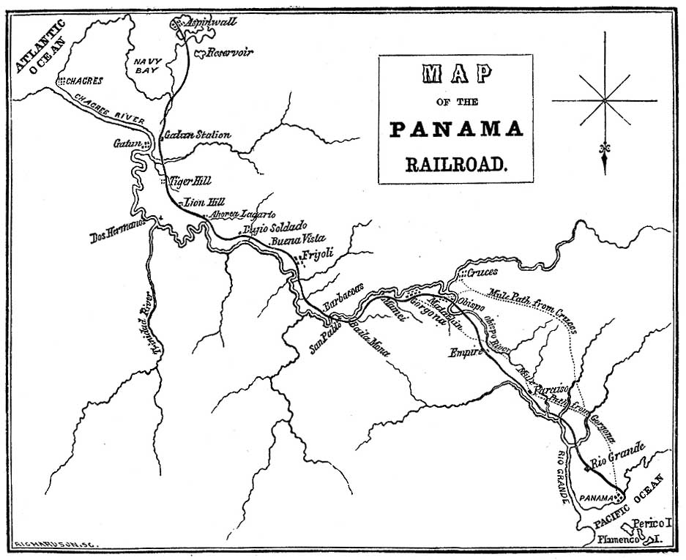
In return, the United States had to guard the “perfect neutrality” of the transportation zone. “Free transit” from the Atlantic to the Pacific was not to be “embarrassed or interrupted,” as the isthmus was to be a global resource. New Granada hoped the treaty would prompt other countries to make similar agreements, thus guaranteeing “universal neutrality.” This did not happen, and the United States became sole guardian of the isthmus’s neutrality.
Figure 1: The Panama Railroad route (from Otis, vii)
Naturally, the acquisition of California following the Mexican-American War increased attention on the Panama route. In an effort to better connect both coasts, Congress authorized two steamship lines: one from New York to Chagres (on Panama’s Atlantic coast) and one from Oregon to Panama City (on Panama’s Pacific Coast). A wealthy import-export magnate from New York named William Henry Aspinwall purchased the contract for the Pacific line; this caused many of his peers to question his judgment, as gold had not yet been discovered in California. Yet the steamship contract was only part of Aspinwall’s plan. He and his business partners presented to Congress in late 1848 regarding the importance of a railroad across Panama; since the cost was so prohibitive, they requested government funding. After much deliberation, Congress granted the men no more than $250,000 per year, while also setting rates for passengers and freight for the first ten years of operation. The Panama Railroad Company was incorporated in 1849, and its first $1 million in capital stock sold out in less than a day. Aspinwall had secured the beginnings of a transportation monopoly.
Construction began in 1850, and it would not cease until 1855. The nascent Gold Rush increased the urgency of the railroad project, but it also increased its difficulty. Traditionally, Panamanians ferried passengers and cargo via the Chagres River on small boats (bungos); depending on water depth, they disembarked at either Gatun or Cruces, both towns along the river. From there, passengers either walked or rode mules the rest of the way to Panama City. Local laborers, quite accustomed to this system, avoided railroad work in large numbers; thus, the Railroad Company had to import workers from Jamaica, China, Ireland, and other parts of Nueva Granada. Despite the shortage of local labor, the railroad made money much earlier than intended. In 1851, California-bound ships approached Aspinwall in a nasty storm. Passengers demanded to be taken as far as Gatun by railroad, then by boat the rest of the way to Panama City. Early on, the Company learned that “all the railroad needed to do to generate revenue was to offer [passengers] a faster and relatively more comfortable transit for part of the way across.”
Bit by bit, the railroad pushed the traditional transportation patterns aside. While it was mostly men that did the ferrying upriver, it was women who set up businesses along the route; they sewed clothes, ran hotels, and sold food and drink (and occasionally engaged in prostitution). As the Gold Rush dramatically increased demand for these services, entrepreneurial businessmen and –women along the transit route enjoyed unprecedented prosperity. However, the railroad gradually took over. It consolidated control over remaining mule traffic; Aspinwall also shifted the base of Atlantic operations from Chagres to a new company town: Colon (after Christopher Columbus), or Aspinwall—across Navy Bay from the traditional entrepot for isthmian bungo transport. In short, even before the completion of the railroad in 1855, Aspinwall and his associates had succeeded in supplanting the preexisting transportation economy.
The railroad remained profitable until the late 1860s. Symbolically, one would expect that the 1869 merger at Promontory Point to be a major turning point; however, it was an 1870 dispute with the Pacific Steam Navigation Company (a steamship line running from Panama City to Valparaiso) that marked the beginning of the end. After that, the Pacific Steam avoided Panama and used Cape Horn routes instead. The railroad’s stock prices plunged 81% as a result. Seeing the writing on the wall, the United States sent expeditions (1870 and 1875) to Panama in search of a canal site. In 1877, Lessep’s Compagnie Universelle du Canal Interoceanique began negotiations to purchase the railroad; they succeeded in 1881. The history of the railroad is thus somewhat circular—the French, after failing in the 1830s, finally gained control. America moved on to another form of transcontinental transport, which retained the corrupt methods of its Panamanian predecessor (while adding numerous other flourishes).
Historiography
While the Panama Canal has inspired more books and articles, the Panama Railroad has not been entirely ignored. Its histories from the late-nineteenth and early-twentieth century histories are usually meshed with travel narratives, which can include shipping rates, hotel choices, and steamship connections. Mid-twentieth century sources tend to stress the marvel of the railroad as a technological innovation. Starting in the 1970s, however, historians began situating the railroad in a broader social context with more attention to the Panamanian experience. The two most recent works on the railroad take a divergent path: one examines the project through a capitalistic lens, while another addresses the ways in which the railroad disrupted local networks of transportation and labor. In short, while academically overshadowed by the canal, the historiography of the Panama Railroad is nonetheless important in unpacking American attitudes toward Central America and Manifest Destiny in general.
Fessenden N. Otis’s 1861 history (mentioned in the introduction) is a quintessential business history. Otis includes stories of important people, but also timetables for steamship connections, charts for currency exchange, and duties levied on certain goods; his audience needs to know these things should they choose to conduct business in (or, more accurately, through) Panama. Otis stresses the railroad as a universal good in somewhat purple prose:
In ancient or in modern times there has, perhaps, been no one work which in a few brief years has accomplished so much, and which promises for the future so great benefit to the commercial interests of the world, as the present railway thoroughfare between the Atlantic and Pacific Oceans at the Isthmus of Panama.

Of course, Otis could not predict that an even more spectacular machine would take its place. Interestingly, though, a history from 1928—and thus, written after the canal—still views the railroad in similar terms. Jean Heald’s Picturesque Panama is oriented more toward the traveler than the businessman; she includes massive amounts of photos, as well as advice on shops and hotels. In contrast to Otis, Heald’s audience is most likely visiting for pleasure as part of the early twentieth century American obsession with the tropics. Nevertheless, their rhetoric is similar. Heald describes the railroad as “a service to the public” which has “dealt successfully with every problem of commerce.” Most importantly, she argues that “as a part of the Panama Canal its interests are the interests of civilization.” Thus, with or without knowledge of the eventual canal, Otis and Heald hit many of the same overall points regarding the importance of trans-isthmian commerce. Their respective audiences are more telling, indicating the transition between commercial and touristic neocolonialism occurring from the 1860s to the 1920s.
The economic emphasis on the railroad’s history persisted, probably as a consequence of the available source base. John Haskell Kemble’s The Panama Route (1943) focuses mostly on the railroad’s legislative underpinnings and rate structure between 1848 (Bidlack-Mallarino) and 1869 (Promontory Point), reifying an Anglocentric periodization of an international issue. Like others before him, Kemble marvels at the sheer communicative power and economic impact of the system. He does, however, introduce an interesting and ironic bent: California heard of its admission to the Union by the steamer California, plying its trade from Panama City. The telegraph, too, figures largely into Kemble’s work; he argues that, from its inception until 1861, the Panama Railroad was “the principal means of communicating intelligently between” both coasts. Despite its somewhat dry statistical bent, The Panama Route recognizes that Panama was an integral part of America’s bicoastal game of telephone.
Joseph Schott’s Rails Across Panama takes a similar approach to the railroad, utilizing a periodization (1849-55, or the Gold Rush era) significant mostly to American readers. Schott also utilizes metaphors—like the chapter titled ‘The Rubicon is Passed’—that echo within his own country’s history. Focusing mostly on technical details like grading, metals, and lumber, he transforms a complicated transcontinental system into a narrative of linear progress. Kemble and Schott do much to expose the way American historical periodization can coopt distant events. There is an irony to transcontinental communiqués being filtered through a foreign country, but neither scholar explores this in depth.
The first work to really explore the railroad critically is Alex Perez-Venero’s Before the Five Frontiers. As a whole the book covers Panamanian history from its 1821 independence from Spain to its 1903 independence from Colombia; this adds many new wrinkles to the Anglocentric version of the Panama Railroad’s history. For example, while it is obvious that the Gold Rush helped popularize the project, Perez-Venero points out that an 1847 depression spurred much of the local goodwill towards the railroad. Nueva Granada’s central government also took away import duties from Panamanians themselves, solidifying their desire for commercial development. Perez-Venero laments the “continual suffering, economic and spiritual, of Panamanians at the hands of extraneous political elements.” He argues that the isthmus’s history relates “either to desires for self-government (usually in the direction of commercial aspirations) or to regrets and disappointments at the outcome of such enterprises." The tension between these two poles of economic independence and eventual disappointment informs much of the book. Perez-Venero portrays Panama as caught between two powers—Colombia and the United States—neither of which “top to take into consideration in their treatment of Panama, the internal turmoil of life on the Isthmus caused by the sudden influx of men and bustling life and its needs, the use of its resources and of its peoples.” While many historiographic strains examine how the railroad connected America, Perez-Venero introduces the idea that it tore Panama asunder.
Perhaps the most complete treatment of the railroad is Aims McGuinness’s Path of Empire, published in 2008. McGuinness is drawn to the ways that Aspinwall’s project replaced existing means of trans-isthmian transport, thus dislodging a lot of local Panamanian lifeways. This shift had international repercussions, as well—McGuinness chronicles the "contested transformation” of isthmian transport “from a locally controlled network powered primarily by human beings, mules, currents, and the wind to a more centralized and largely US-owned network of ships and locomotives powered by steam." Thus, the sovereignty guaranteed Panama in the Bidlack-Mallarino treaty was gradually usurped by American commercial interests. McGuinness sets forth his own definition of sovereignty: “the organization and the enactment of power over territory and flows of people, information, and goods through governmental and extra-governmental means." Panamanians were never able to achieve this kind of control over the railroad. Like Richard White’s Railroaded, Path of Empire pays great attention to a corrupt system given immense aid by the federal government. Add the swarm of steamship contracts and the Gold Rush, and Panama was literally in the path of a nascent empire
While McGuinness’s work comes from a postcolonial perspective, the newest work on the Panama Railroad falls squarely within the ascendant ‘history of capitalism’ genre. Noel Maurer and Carlos Yu’s The Big Ditch is a history of the Panama Canal, but its treatment of the railroad stands out as both original and derivative. Echoing late-nineteenth century neocolonialism, Maurer and Yu approach the railroad as a cost/benefit proposition. Their writing is studded with charts, most of them concerning monetary transactions; they make liberal use of John Haskell Kemble’s records of passenger flows and specie transport via the railroad (naturally, big business during the Gold Rush). Maurer and Yu even calculate the average return on the Panama Railroad Company’s stock from 1853-1880. Eschewing racial and cultural analysis, they historicize the isthmus as an important crossing point for many historic commodity flows. This leads them to conclude that the railroad was actually the second Panama boom; they argue that, like the first boom, it ended because of economic competition. It is an interesting commentary on the Panama Railroad that its most recent scholarly treatment focuses on economic impact instead of cultural ramifications. I suspect this is a commentary on the archival silences that await cultural historians of nineteenth-century Panama.
Primary Sources
As mentioned above, two primary sources from 1849 and 1861 offer us a unique window into what scholars have termed Latin America’s neocolonial period. After independence movements in the 1820s, many countries experienced major influxes of foreign capital to declare the nascent republics ‘open for business.’ Both the 1849 proposal for the railroad and Otis’s 1861 history of the project reveal certain attitudes of the period in perfect clarity: a sense of Manifest Destiny (even via international means), a racialized environmental determinism regarding the jungle, and a desire to foreground international business connections. It should come as no surprise to the reader that both documents utilize purple prose in their pursuance of the above goals. Their most important parallel, I argue, is their spatial determinism regarding the ishthmus’s geographic location. While many Anglo travelers stereotyped jungles as unhealthy and impassable, both documents contend that Panama’s perfect positioning outweighed its environmental challenges. Thus, we see a battle between two different determinisms. Environmentally, the isthmus was backwards and unredeemed; spatially, however, it was destined to unite disparate parts of the commercial world.
Travel writings are especially useful sources for historians of Latin America’s neocolonial period. Jordana Dym refers to these authors as the “second generation” of their kind, “possess[ing] surveying skills or the companionship of a geographer not to improve cartography useful to their peers, but to impress investors, colonists and governments with the region's promise as a transit point or commercial depot." While earlier visitors no doubt experienced a more severe “cartographic void,” Dym observes that “businessmen still had to create their own maps to sell their railways and canal dreams to others.” The 1849 promotional tract and Otis’s history vary in their usage of maps. Figuratively, however, both employ similar spatial rhetoric. Both stress Panama as “a place designed by nature for a communication between the Atlantic and Pacific” and “a natural culminating point for the great commercial travel of the globe.” Both portray the railroad and its steamer systems as “great agents of civilization and commerce” and a “highway for all nations.” Like real estate agents, both sources stress ‘location, location, location.’
However, their different historical moments make for interesting differences. Most importantly, the 1849 proposal leans heavily on the logic of reducing distance; it is designed to produce confidence among investors. Most notably, the authors include a table showing the time saved by Panama as opposed to Cape Horn. Otis, writing at a later date (at the threshold of the transcontinental telegraph), shows international steamship connections as the most important contribution of Panama to world systems of commerce. He touts the globalizing effect of the isthmus’s railroad, rather than merely the time the route itself saves. The 1849 document uses space as a temporal framework, while Otis uses space as a backdrop for commercial networks.
The shared cultural moment of these documents reaches beyond commerce and into environmental realms. As Stephen Frankel explains, the Central American tropics were viewed through two interconnected stereotypes: “positive ones about Edenic paradises, fertile soil, and exotic beauty; and negative ones about moral laxity, dangerous landscapes,
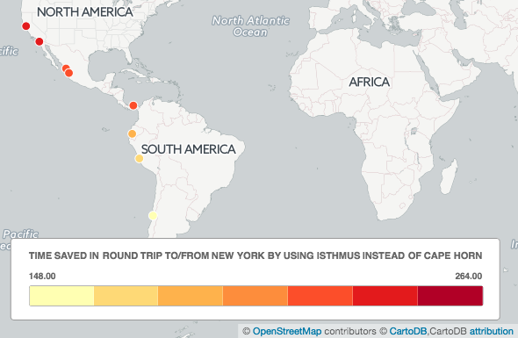
Figure 2: Time saved (in days) via Panama Route versus Cape Horn (from Panama Railroad Company, 14)
disease, and the threatening abundance of the jungle." Just as the jungle was essentialized, so to were its residents. In another work, Frankel applies this framework to the Panama Canal. He identifies environmental determinism’s roots in fin de siècle conceptions of race:
Environmental determinism rationalized a theoretical position by which Americans considered it natural that different races should be treated differently and that races could be ranked according to environmentally based biological differences. In practical application, this meant pay and privileges based on race.

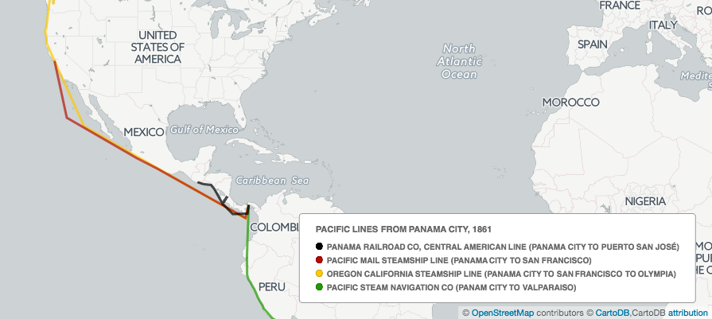
Figure 3: Pacific steamship lines connecting with the Panama Railroad, 1861 (from Otis 147-175)
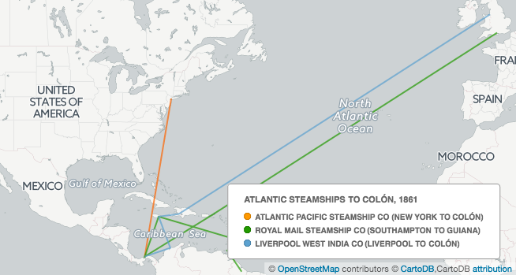
Figure 4: Atlantic steamship lines connecting with the Panama Railroad, 1861 (from Otis, 147-175)
The jungle environment could be marshaled to legitimate discrimination, but this cut two ways; whites were often viewed as unsuitable for hot and humid climates. Both documents address this in some way. The 1849 prospectus notes that engineers (read: white employees) had no trouble with their workload, and that fevers amongst them were common but easier to cure than those in the United States. Otis, writing later, affirms that fever had ceased to be a problem; he asserts that the railroad will “in point of healthiness, compare favorably with many of the equally recent settlements in the Western States." To make the jungle even less menacing, Otis essentially denies its human habitation: the railroad “affords to the traveler but little of historic interest apart from its own construction, passing as it does through the heart of a primeval tropical forest for many miles of its extent." Together, these documents show the pervasive interconnection between health and environment. While the isthmus’s geographic position spoke for itself, its humid and vine-infested environs needed to be surmounted in some way. By discounting environmental difficulties, both sources elide any cultural conflict in the building of the railroad as well.
Despite the relative environmental disjuncture between the United States and Panama, both sources stress the physical proximity between them. They tout the railroad as a global solution, but one chiefly enjoyed and known by Americans. The 1849 tract stresses the rapidity of this transformation: “…it has, within the space of a few short months...become a great thoroughfare for travel, overrun by Americans, familiar among us as one of our own public roads...fixing the attention of all enlightened men, in Europe and in America." While it is undoubtedly of global interest, the invocation of “our public roads” is telling. The recent acquisition of California (after war with Mexico) forms an important backdrop to this discourse. The Panama Railroad could foster “a large population on the Pacific, whose voice from that distant shore will meet and mingle with the loud call now made for [a railroad across America] by their kinsmen.” Otis makes this even clearer. While America’s new territories were desirable, “their distance rendered them almost inaccessible to the class of emigrants who usually settle our new domains, as well as inconvenient to the proper administration of law and government." Otis argues that Panama can actually help America administer its new territory. While Panama remained an object of the exotic, its railroad connection promised to further bureaucratic and cultural unity within the United States.
Whether via temporal or network-based logic, both the promotional tract and the railroad’s official history are inherently spatial documents. Any close examination of the Panama Railroad must reconcile two different concepts—environmental and spatial determinism. Scholars have done exceedingly well unpacking the cultural perceptions at work in America’s relationship to the tropics. Documents rich in this essentialist rhetoric need not support only one mode of analysis, though. Histories of overland migration and Manifest Destiny often focus on chokepoints—South Pass, Donner Pass, Tejon Pass, or any number of gateways to the American West. We must add the isthmus of Panama to this list if we are to understand the predecessors of the transcontinental railroad. Similarly, we must address Panama’s role in the incorporation of previously Mexican territory; the Gold Rush made the railroad profitable, but desires to communicate with California made the railroad—and its steamship networks—indispensable. It is well known that mid-nineteenth century rhetoric focused on the inevitability of a transcontinental America. As the Panama Railroad shows, however, these calls were routed through a tropical third party.

Noel Maurer and Carlos Yu, The Big Ditch: How America Took, Built, Ran, and Ultimately Gave Away the Panama Canal (Princeton: Princeton University Press, 2011), 17-30.
Alex Perez-Venero, Before the Five Frontiers: Panama, from 1821-1903 (New York: AMS Press, 1978), 53.
Ibid, 54-5.
Quoted in Maurer and Yu, 45.
Ibid.
Ibid, 36.
Perez-Venero, 59.
Ibid, 61.
Ibid, 63.
See Figure 1 (previous page).
Aims McGuinness, Path of Empire: Panama and the California Gold Rush (Ithaca: Cornell University Press, 2008), 33.
Maurer and Yu, 43.
Ibid, 45.
McGuinness, 36.
Ibid, 37.
Ibid, 68.
Maurer and Yu, 49.
Ibid, 54.
Ibid, 49.
See Richard White, Railroaded: The Transcontinentals and the Making of Modern America (New York: W.W. Norton and Co., 2012).
Fessenden N. Otis, “Illustrated History of the Panama Railroad;” (Harper & Bros., 1861), 15, https://archive.org/stream/illustratedhist01otisgoog#page/n160/mode/2up.
Jean Sadler Heald, Picturesque Panama : The Panama Railroad, the Panama Canal (Chicago : C. Teich & Co., 1928), 100.
John Haskell Kemble, The Panama Route, 1848-1869 (Berkley and Los Angeles: University of California Press, 1943), 205.
Ibid, 209.
Alex Perez-Venero, Before the Five Frontiers (New York: AMS Press, 1978), 54.
Ibid, 69.
Ibid, ix.
Ibid, 91.
McGuinness, 9. For an in-depth treatment of the role of technology in American neocolonialism, see Ricardo Donato Salvatore, “Imperial Mechanics: South America’s Hemispheric Integration in the Machine Age,” American Quarterly 58, no. 3 (2006): 662–91.
Ibid.
It was 13.7%, much higher than the New York Stock Exchange’s average over the same period. Maurer and Yu, 47.
Ibid, 14.
See McGuinness 2-4 for anecdotes on the complexity of archival research in Panama.
Jordana Dym, “‘More Calculated to Mislead than Inform’: Travel Writers and the Mapping of Central America, 1821-1945,” Journal of Historical Geography 30, no. 2 (2004): 348.
Ibid.
Panama Railroad Company, Panama Rail-Road Company. Capital $1,000,000, with Liberty to Increase to $5,000,000 .. (New York, 1849), http://hdl.handle.net/2027/uc1.31822031028533.
Otis, 15.
Panama Railroad Company, 16.
Otis, 35.
See Figure 2.
See Figures 3 and 4.
Stephen Frenkel, “Jungle Stories: North American Representations of Tropical Panama,” Geographical Review 86, no. 3 (1996): 317–18.
Stephen Frenkel, “Geography, Empire, and Environmental Determinism,” Geographical Review 82, no. 2 (1992): 149.
Panama Railroad Company, 7-8.
Otis, 49.
Ibid, 80.
See Conevery Bolton Valenčius, The Health of the Country: How American Settlers Understood Themselves and Their Land (New York: Basic Books, 2002) for an examination of this phenomenon in the southern United States
Panama Railroad Company, 4.
Ibid, 20.
Otis, 16.

